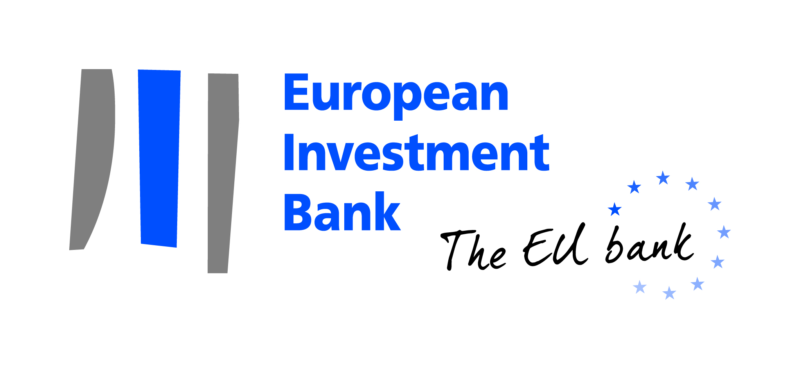
PRESS RELEASE

Luxembourg, 26 October 2017

EIB DONATES EUR 250 000 FOLLOWING HURRICANES IN THE CARIBBEAN AND EARTHQUAKES IN MEXICO
The European Investment Bank (EIB) will provide a EUR 250 000 donation to emergency aid agencies following two recent major natural catastrophes that struck the Caribbean and Mexico.
In September, Irma and Maria, two hurricanes of exceptional strength caused widespread and catastrophic damage across the Caribbean. Also in September, two powerful earthquakes wrought havoc in Mexico City, and off the country's southern coast.
The EIB Group, in an effort coordinated by the EIB Institute, raised money among its staff, which was topped up by the Bank itself, and decided to donate EUR 250 000 to help the victims of these catastrophes.
The beneficiaries will be Save the Children (Spain), Red Cross (in The Netherlands, France, UK and the Federation of Red Cross and Red Crescent Societies based in Switzerland), Médecins du Monde (Luxembourg), CARE (Luxembourg) and UNICEF (The Netherlands).
Many of these agencies have previously worked with the EIB through the EIB Institute, its philanthropic arm, following previous humanitarian relief donations.
EIB Vice-President Pim van Ballekom, in charge of overseeing operations in the Caribbean and responsible for the EIB Institute, said: “Today’s announcement underlines the commitment of both the EIB as an organisation and its staff to supporting the victims of humanitarian catastrophes. The local populations are bouncing back from this tragedy with remarkable resolve and deserve all the help they can get.”
The EIB Group has in the recent past contributed to relief efforts for other humanitarian disasters including the Italian earthquake in August 2016, Hurricane Matthew in Haiti in October 2016, the flooding and mudslides in Peru and Colombia in 2017 and the forest fires in Portugal also in 2017.

The European Investment Bank (EIB) is the long-term lending institution of the European Union owned by its Member States. It makes long-term finance available for sound investment in order to contribute towards EU policy goals. Website: www.eib.org
Press Office: +352 4379 21000 – press@eib.org

The EIB Institute was set up within the EIB Group (European Investment Bank and European Investment Fund) to promote and support social, cultural, and academic initiatives with European stakeholders and the public at large. It is a key pillar of the EIB Group’s community and citizenship engagement. Website: http://institute.eib.org/

Press contact: Bruno Rossignol, b.rossignol@eib.org,
Luxembourg, 26 October 2017

